

Through silent determination, a student of Las Piñas National Science High School walks forward, full of determination and confidence, a symbol of her commitment and respect to education. Each step reflected the perseverance behind every sleepless night and endless school works.In the face of challenges, a bright mind and a humble heart work shine brighter together than any medal.

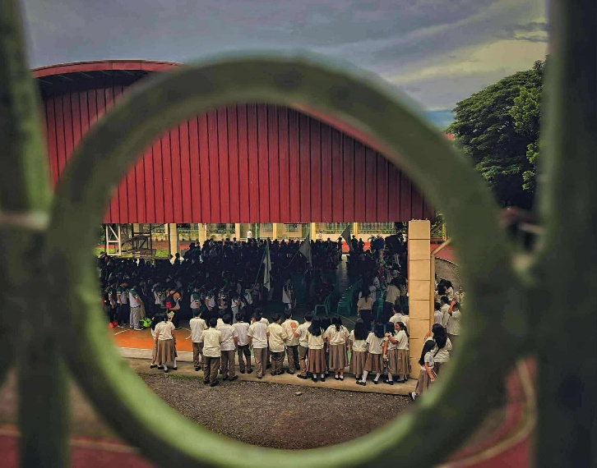
They carry their school colors with grace, every step rising as a symbol of honor and representation. In every banner held high, LPSCI reminded everyone that pride was not only seen, it was felt. In that moment, honor spoke louder than words.



They pour their energy into every chant, proving that pride lives in unity. When LPSCI cheered together, even the walls learned to echo their name. In that roar, pride turned into power.

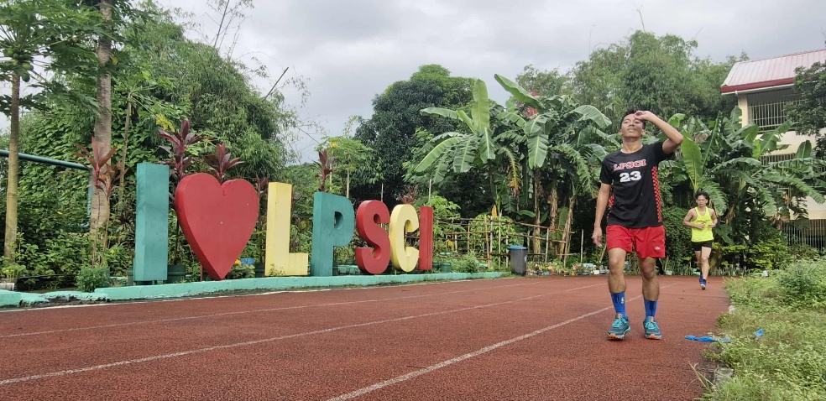
He battles through every stride with determination, holding his ground even as exhaustion tries to claim his strength. In the heat of Clusters Meet, true strength is measured by the heart that keeps running. In that race, courage outruns fatigue.

Yeuffa Yumiko R. Gata
Mary Nicole S. Manguerra
9-Fidelity

